Develop a vb project to sort the numbers using ripple sort

Form design:

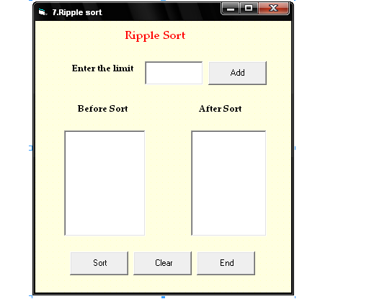

Porperties:

Controls | Name | Caption
Text1 | Text1
List1 | List1
List2 | List2
Command1 | Cmdadd | Add
Command2 | Cmdsort | Sort
Command3 | Cmdclear | Clear
Command4 | Cmdend | End

7.Ripplesort
Aim:
To develop a vb project to sort the numbers using ripple sort

Coding:
Dim a(50) As Integer
Dim i, j, n As Integer
Dim noofentries, nooftimes As Integer

Private Sub Cmdsort_Click()
noofentries = n
nooftimes = noofentries - 1
For i = LBound(a) To nooftimes
For j = i + 1 To noofentries
If a(j) < a(i) Then
swap a(j), a(i)
End If
Next j
Next i
For i = 1 To n
List2.AddItem (a(i))
Next i
End Sub

Sub swap(x As Integer, y As Integer)
Dim temp
temp = x
x = y
y = temp
End Sub

Private Sub Cmdclear_Click()
Text1.Text = " "
List1.Clear
List2.Clear
End Sub

Private Sub Cmdend_Click()
End
End Sub

Private Sub Cmdadd_Click()
n = Val(Text1.Text)
For i = 1 To n
a(i) = InputBox("Enter the number")
List1.AddItem (a(i))
Next i
End Sub

Output:

